**A Complete Reinforcement Learning System**

**Nguyễn Hoàng Việt – QE170216**

**AI17C**

**REL301m**

1. **Certificate**

Link: <https://coursera.org/share/05f5b4c245824afa92867fcdb7cb62cb>

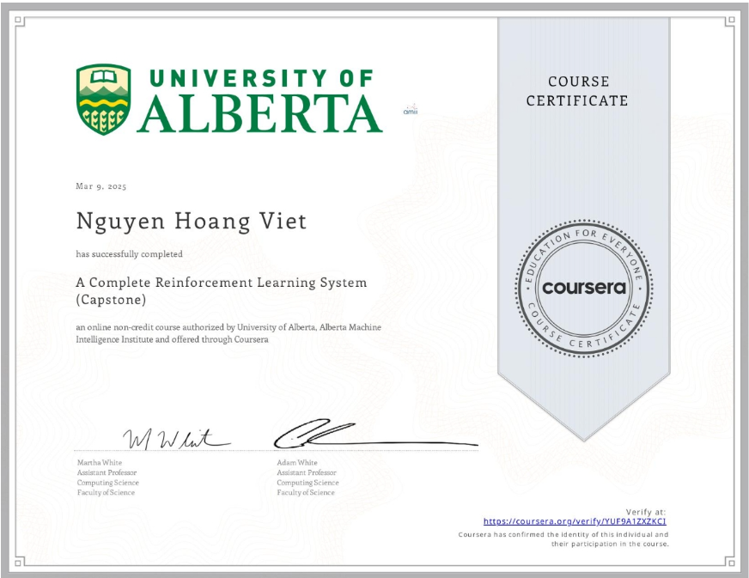

1. **Assignment**

* **MoonShot Technologies**: link github
* **SImplement Your Agent:** link github
* **Completing the parameter study:** link github

1. **Quiz**

* Choosing the Right Algorithm

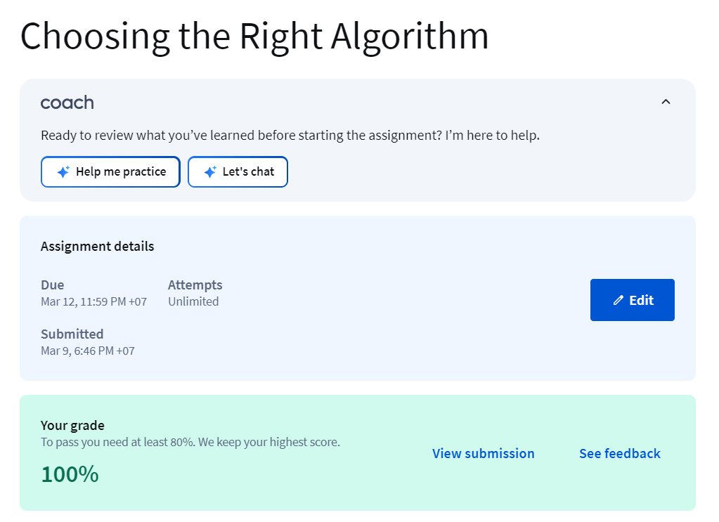

* Impact of Parameter Choices in RL

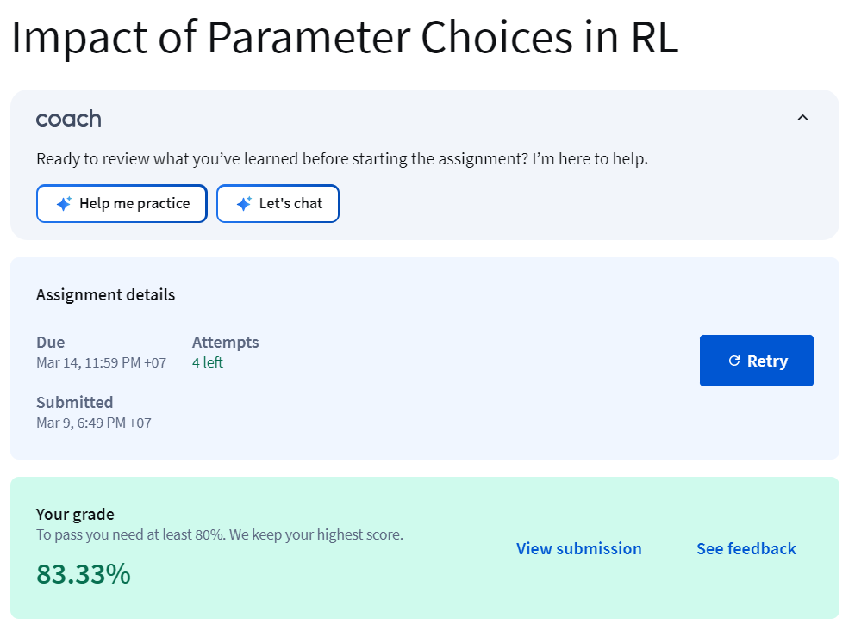

* Total:

